Amit Nijjar, I worked alone

A11489111

4/17/17

CSE 105 HW 3

1. 1. True. You can create a dfa for any regular language and with enough states, you can ensure that there is a dfa such that there is one accept state. You can make different paths to the accept state to cover all strings in the language.
   2. True. Same logic for the dfa.
2. 1. L\* is the Kleene star of L or the Klelene star of {a, b, c}. This means L\* is {(ε, "a", "b", "c", “ab”, “ac”,… )a} (Every combination of an unlimited number of a’s, b’s, and c’s including the combination that is the empty set followed by an a.)
   2. The NFA of L, L(N) is:

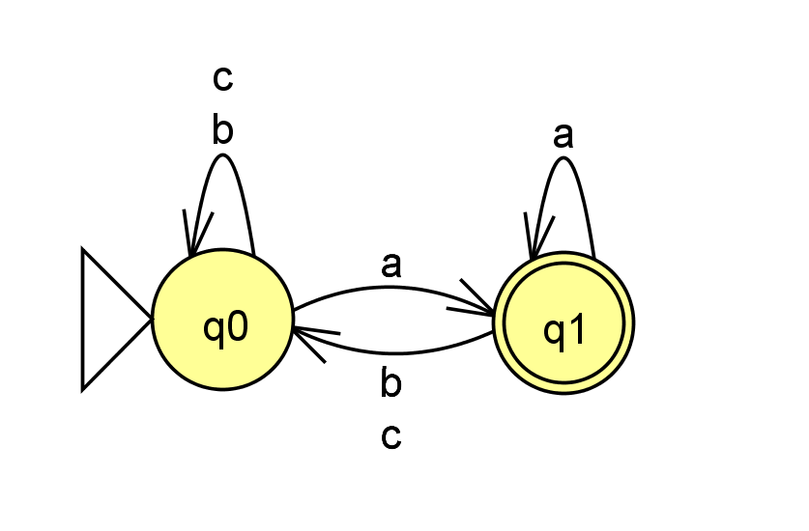

L(N^) is:

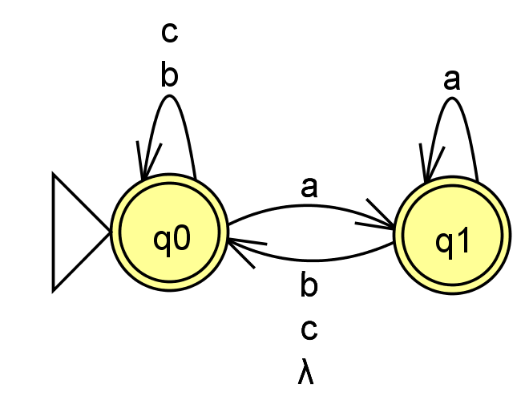

L(N^) is not equal to L\* because the original initial state has become an accept state instead of adding another buffer state. This can result in other paths being accepted by the NFA.

Good NFA for L\*:

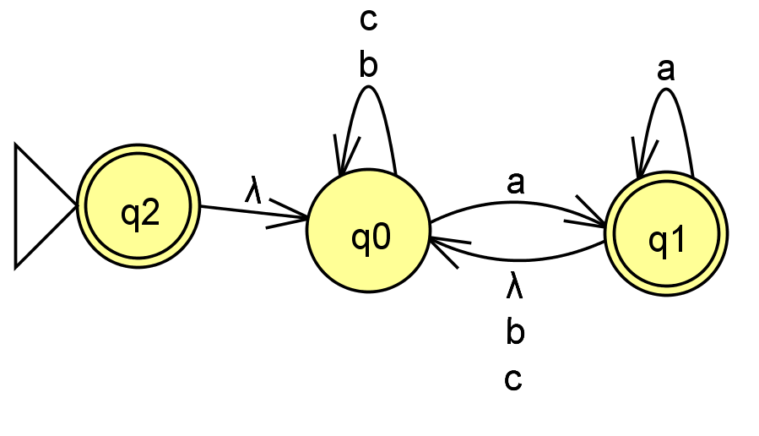

This NFA is correct as it makes another state for the initial state. By doing so, it allows for the empty string to be a part of the accepted strings.

1. B and I both represent the same language, the language of all strings over {0, 1}. A and D both represent the same language, the language of strings of 01 or 10 over {0, 1}. E and H both represent the same language, the language of strings of 01 over {0, 1}. F and G both represent the same language, the language of strings 0 followed by strings 10 over {0, 1}. C and J both represent the same language, the language of strings of 0 following 10, ending with 1 over {0, 1}.
2. 1. NFA:

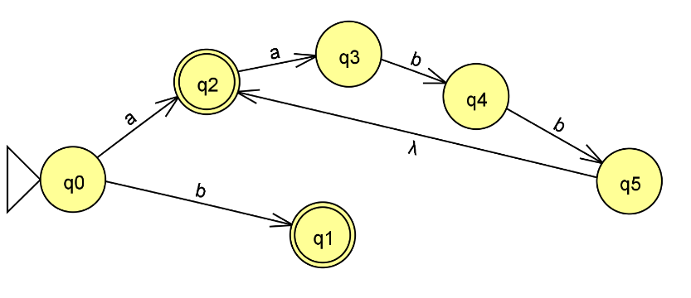

<?xml version="1.0" encoding="UTF-8" standalone="no"?><!--Created with JFLAP 6.4.--><structure>&#13;

<type>fa</type>&#13;

<automaton>&#13;

<!--The list of states.-->&#13;

<state id="0" name="q0">&#13;

<x>272.0</x>&#13;

<y>491.0</y>&#13;

<initial/>&#13;

</state>&#13;

<state id="1" name="q1">&#13;

<x>476.0</x>&#13;

<y>378.0</y>&#13;

<final/>&#13;

</state>&#13;

<state id="2" name="q2">&#13;

<x>651.0</x>&#13;

<y>331.0</y>&#13;

</state>&#13;

<state id="3" name="q3">&#13;

<x>849.0</x>&#13;

<y>348.0</y>&#13;

</state>&#13;

<state id="4" name="q4">&#13;

<x>1073.0</x>&#13;

<y>512.0</y>&#13;

</state>&#13;

<state id="5" name="q5">&#13;

<x>575.0</x>&#13;

<y>534.0</y>&#13;

<final/>&#13;

</state>&#13;

<!--The list of transitions.-->&#13;

<transition>&#13;

<from>0</from>&#13;

<to>5</to>&#13;

<read>b</read>&#13;

</transition>&#13;

<transition>&#13;

<from>0</from>&#13;

<to>1</to>&#13;

<read>a</read>&#13;

</transition>&#13;

<transition>&#13;

<from>1</from>&#13;

<to>2</to>&#13;

<read>a</read>&#13;

</transition>&#13;

<transition>&#13;

<from>3</from>&#13;

<to>4</to>&#13;

<read>b</read>&#13;

</transition>&#13;

<transition>&#13;

<from>4</from>&#13;

<to>1</to>&#13;

<read/>&#13;

</transition>&#13;

<transition>&#13;

<from>2</from>&#13;

<to>3</to>&#13;

<read>b</read>&#13;

</transition>&#13;

</automaton>&#13;

</structure>

* 1. DFA:

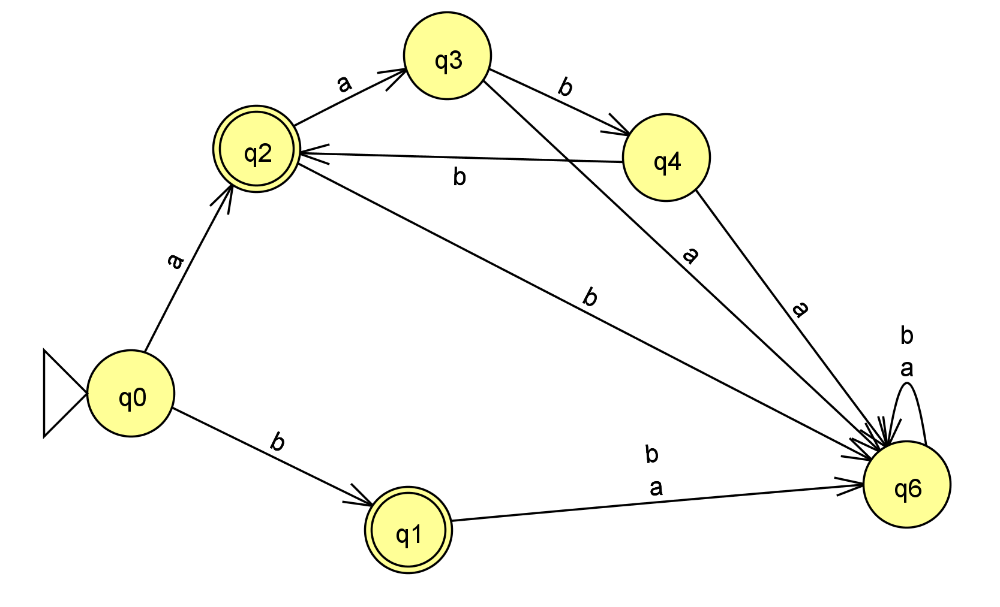

<?xml version="1.0" encoding="UTF-8" standalone="no"?><!--Created with JFLAP 6.4.--><structure>&#13;

<type>fa</type>&#13;

<automaton>&#13;

<!--The list of states.-->&#13;

<state id="0" name="q0">&#13;

<x>230.0</x>&#13;

<y>730.0</y>&#13;

</state>&#13;

<state id="1" name="q1">&#13;

<x>452.0</x>&#13;

<y>341.0</y>&#13;

</state>&#13;

<state id="2" name="q2">&#13;

<x>698.0</x>&#13;

<y>180.0</y>&#13;

</state>&#13;

<state id="3" name="q3">&#13;

<x>910.0</x>&#13;

<y>341.0</y>&#13;

</state>&#13;

<state id="4" name="q4">&#13;

<x>1062.0</x>&#13;

<y>625.0</y>&#13;

</state>&#13;

<state id="5" name="q5">&#13;

<x>605.0</x>&#13;

<y>743.0</y>&#13;

</state>&#13;

<!--The list of transitions.-->&#13;

<transition>&#13;

<from>4</from>&#13;

<to>4</to>&#13;

<read>a</read>&#13;

</transition>&#13;

<transition>&#13;

<from>2</from>&#13;

<to>3</to>&#13;

<read>b</read>&#13;

</transition>&#13;

<transition>&#13;

<from>4</from>&#13;

<to>4</to>&#13;

<read>b</read>&#13;

</transition>&#13;

<transition>&#13;

<from>0</from>&#13;

<to>5</to>&#13;

<read>b</read>&#13;

</transition>&#13;

<transition>&#13;

<from>1</from>&#13;

<to>4</to>&#13;

<read>b</read>&#13;

</transition>&#13;

<transition>&#13;

<from>3</from>&#13;

<to>4</to>&#13;

<read>a</read>&#13;

</transition>&#13;

<transition>&#13;

<from>2</from>&#13;

<to>4</to>&#13;

<read>a</read>&#13;

</transition>&#13;

<transition>&#13;

<from>0</from>&#13;

<to>1</to>&#13;

<read>a</read>&#13;

</transition>&#13;

<transition>&#13;

<from>1</from>&#13;

<to>2</to>&#13;

<read>a</read>&#13;

</transition>&#13;

<transition>&#13;

<from>5</from>&#13;

<to>4</to>&#13;

<read>a</read>&#13;

</transition>&#13;

<transition>&#13;

<from>3</from>&#13;

<to>1</to>&#13;

<read>b</read>&#13;

</transition>&#13;

<transition>&#13;

<from>5</from>&#13;

<to>4</to>&#13;

<read>b</read>&#13;

</transition>&#13;

</automaton>&#13;

</structure>

1. I completed the consent form